**HELLO WORLD RESTFUL WEB SERVICE**

**HelloController.java**

package com.cognizant.spring_learn.controller;

import org.slf4j.Logger;

import org.slf4j.LoggerFactory;

import org.springframework.web.bind.annotation.GetMapping;

import org.springframework.web.bind.annotation.RestController;

@RestController

public class HelloController {

private static final Logger LOGGER = LoggerFactory.getLogger(HelloController.class);

@GetMapping("/hello")

public String sayHello() {

LOGGER.info("START sayHello()");

String message = "Hello World!!";

LOGGER.info("END sayHello()");

return message;

}

}

**OUTPUT:**

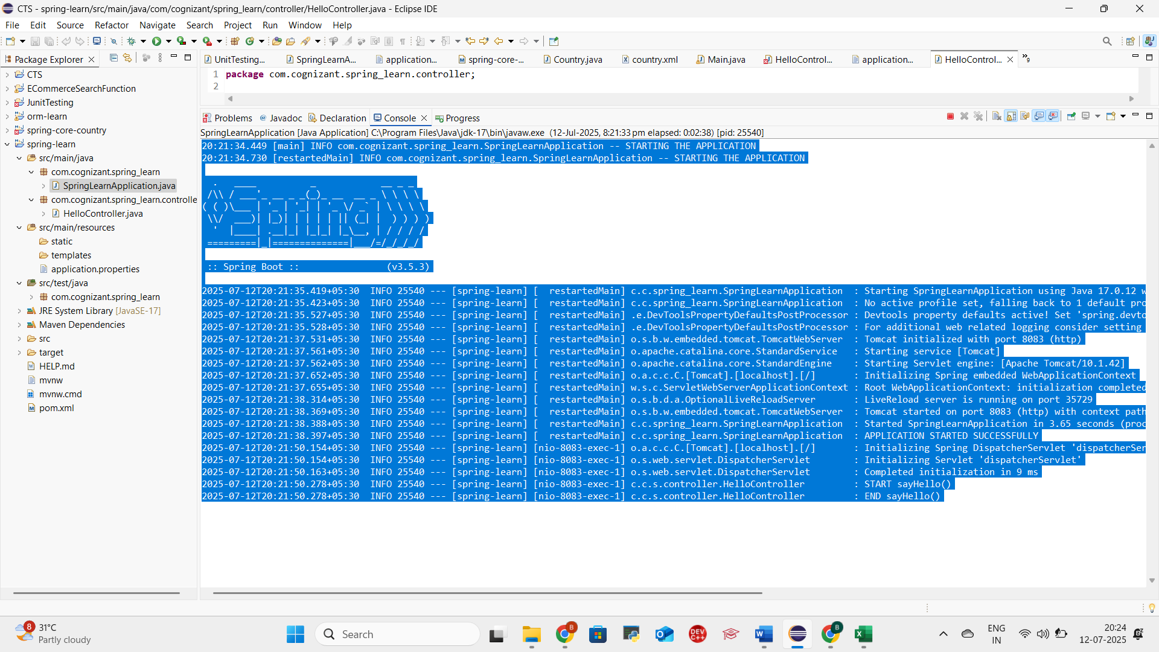

**REST - COUNTRY WEB SERVICE**

**CountryController.java (in controller package)**

package com.cognizant.springlearn.controller;  
  
import com.cognizant.springlearn.model.Country;  
import com.cognizant.springlearn.service.CountryService;  
import com.cognizant.springlearn.service.exception.CountryNotFoundException;  
import org.springframework.beans.factory.annotation.Autowired;  
import org.springframework.web.bind.annotation.*;  
  
import java.util.List;  
  
@RestController  
public class CountryController {  
  
 @Autowired  
 private CountryService countryService;  
  
 // GET: /country → returns India  
 @GetMapping("/country")  
 public Country getCountryIndia() {  
 return new Country("IN", "India");  
 }  
  
 // GET: /countries → returns all countries  
 @GetMapping("/countries")  
 public List<Country> getAllCountries() {  
 return countryService.getAllCountries();  
 }  
  
 // GET: /countries/{code} → returns a country by code  
 @GetMapping("/countries/{code}")  
 public Country getCountry(@PathVariable String code) throws CountryNotFoundException {  
 return countryService.getCountry(code);  
 }  
}

**Country.java (in model package)**

package com.cognizant.springlearn.model;  
  
public class Country {  
 private String code;  
 private String name;  
  
 public Country() {}  
  
 public Country(String code, String name) {  
 this.code = code;  
 this.name = name;  
 }  
  
 public String getCode() {  
 return code;  
 }  
  
 public void setCode(String code) {  
 this.code = code;  
 }  
  
 public String getName() {  
 return name;  
 }  
  
 public void setName(String name) {  
 this.name = name;  
 }  
}

**CountryService.java (in service package)**

package com.cognizant.springlearn.service;  
  
import com.cognizant.springlearn.model.Country;  
import com.cognizant.springlearn.service.exception.CountryNotFoundException;  
import org.springframework.stereotype.Service;  
  
import java.util.Arrays;  
import java.util.List;  
  
@Service  
public class CountryService {  
  
 private static final List<Country> *countries* = Arrays.*asList*(  
 new Country("IN", "India"),  
 new Country("US", "United States"),  
 new Country("JP", "Japan"),  
 new Country("DE", "Germany")  
 );  
  
 public Country getCountry(String code) throws CountryNotFoundException {  
 return *countries*.stream()  
 .filter(c -> c.getCode().equalsIgnoreCase(code))  
 .findFirst()  
 .orElseThrow(() -> new CountryNotFoundException("Country not found"));  
 }  
  
 public List<Country> getAllCountries() {  
 return *countries*;  
 }  
}

**CountryNotFoundException.java (in service.exception package)**

package com.cognizant.springlearn.service.exception;  
  
import org.springframework.http.HttpStatus;  
import org.springframework.web.bind.annotation.ResponseStatus;  
  
@ResponseStatus(value = HttpStatus.*NOT_FOUND*, reason = "Country not found")  
public class CountryNotFoundException extends Exception {  
 public CountryNotFoundException(String message) {  
 super(message);  
 }  
}

1. [**http://localhost:8080/countries**](http://localhost:8080/countries) **(to display all countries)**

1. [**http://localhost:8080/countries/in**](http://localhost:8080/countries/in) **(to display specific country)**

**REST - GET COUNTRY BASED ON COUNTRY CODE**

**Path: src/main/resources/country.xml**

<?xml version="1.0" encoding="UTF-8"?>

<beans xmlns="http://www.springframework.org/schema/beans"

xmlns:xsi="http://www.w3.org/2001/XMLSchema-instance"

xsi:schemaLocation="http://www.springframework.org/schema/beans

https://www.springframework.org/schema/beans/spring-beans.xsd">

<bean id="countryList" class="java.util.ArrayList">

<constructor-arg>

<list>

<bean class="com.cognizant.spring_learn.model.Country">

<property name="code" value="IN"/>

<property name="name" value="India"/>

</bean>

<bean class="com.cognizant.spring_learn.model.Country">

<property name="code" value="US"/>

<property name="name" value="United States"/>

</bean>

<bean class="com.cognizant.spring_learn.model.Country">

<property name="code" value="DE"/>

<property name="name" value="Germany"/>

</bean>

<bean class="com.cognizant.spring_learn.model.Country">

<property name="code" value="JP"/>

<property name="name" value="Japan"/>

</bean>

</list>

</constructor-arg>

</bean>

</beans>

**CountryService.java**

Path: com.cognizant.spring_learn.service.CountryService

package com.cognizant.spring_learn.service;

import com.cognizant.spring_learn.model.Country;

import org.springframework.context.ApplicationContext;

import org.springframework.context.support.ClassPathXmlApplicationContext;

import org.springframework.stereotype.Service;

import java.util.List;

@Service

public class CountryService {

public Country getCountry(String code) {

ApplicationContext context = new ClassPathXmlApplicationContext("country.xml");

List<Country> countryList = context.getBean("countryList", List.class);

return countryList.stream()

.filter(country -> country.getCode().equalsIgnoreCase(code))

.findFirst()

.orElse(null);

}

}

**CountryController.java**

Path: com.cognizant.spring_learn.controller.CountryController

package com.cognizant.spring_learn.controller;

import com.cognizant.spring_learn.model.Country;

import com.cognizant.spring_learn.service.CountryService;

import org.slf4j.Logger;

import org.slf4j.LoggerFactory;

import org.springframework.beans.factory.annotation.Autowired;

import org.springframework.web.bind.annotation.*;

@RestController

public class CountryController {

private static final Logger LOGGER = LoggerFactory.getLogger(CountryController.class);

@Autowired

private CountryService countryService;

@GetMapping("/countries/{code}")

public Country getCountry(@PathVariable String code) {

LOGGER.info("START getCountry() with code: {}", code);

Country country = countryService.getCountry(code);

LOGGER.info("END getCountry()");

return country;

}

}

http://localhost:8083/countries/in

**Output:**

{

"code": "IN",

"name": "India"

}

<http://localhost:8080/countries/in>

<http://localhost:8080/countries/us>

